Translation Practice -- Garfield

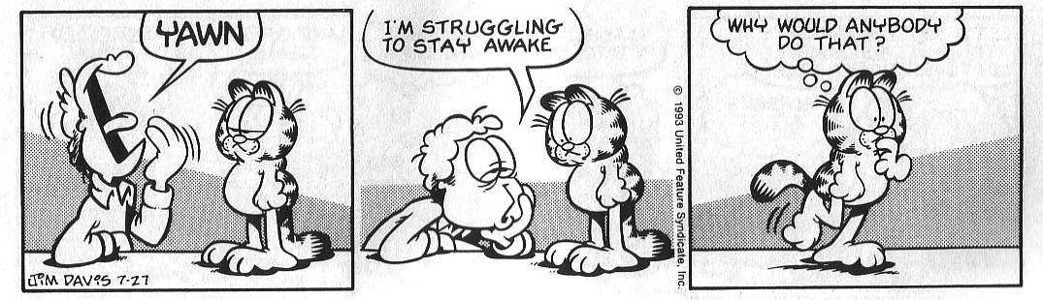

Panel 1: Jon: _____________________________________________________________________

Panel 2: Jon: _____________________________________________________________________

Panel 3: Garfield: _________________________________________________________________

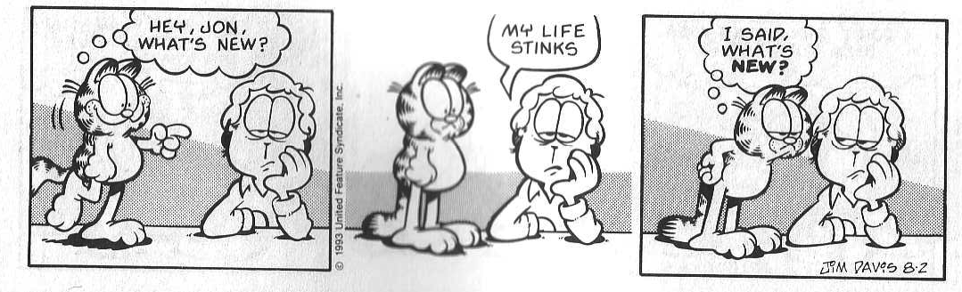

Panel 1: Garfield: _________________________________________________________________

Panel 2: Jon: _____________________________________________________________________

Panel 3: Garfield: _________________________________________________________________

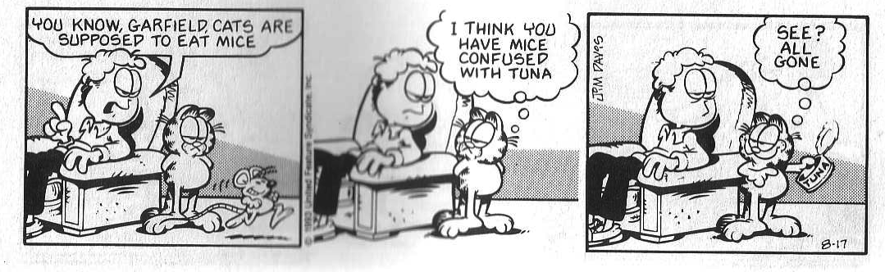

Panel 1: Jon: _____________________________________________________________________

Panel 2: Garfield: _________________________________________________________________

Panel 3: Garfield: _________________________________________________________________

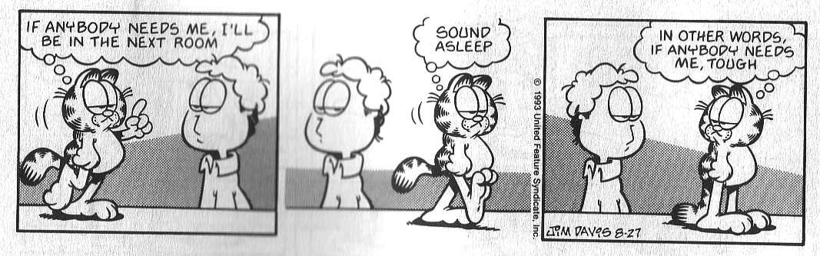

Panel 1: Garfield: _________________________________________________________________

Panel 2: Garfield: _________________________________________________________________

Panel 3: Garfield: _________________________________________________________________

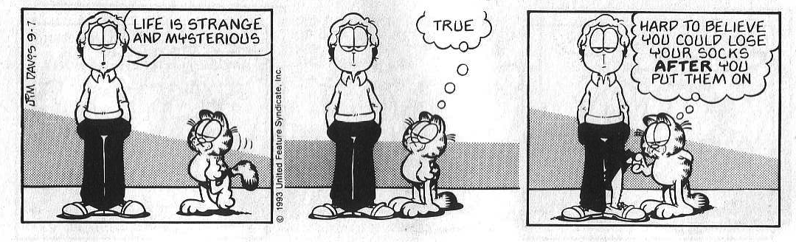

Panel 1: Jon: _____________________________________________________________________

Panel 2: Garfield: _________________________________________________________________

Panel 3: Garfield: _________________________________________________________________

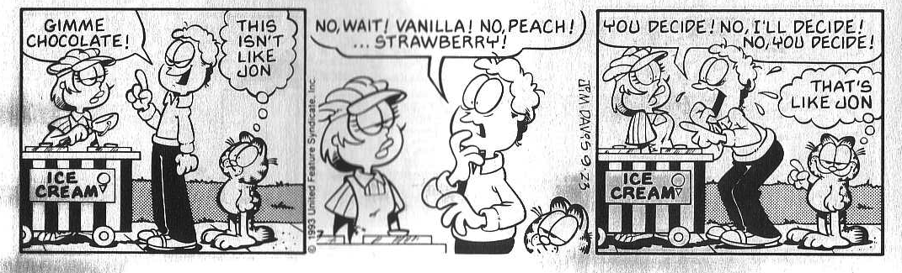

Panel 1: Jon: _____________________________________________________________________

Garfield: _________________________________________________________________

Panel 2: Jon: _____________________________________________________________________

Panel 3: Jon: _____________________________________________________________________

Garfield: _________________________________________________________________